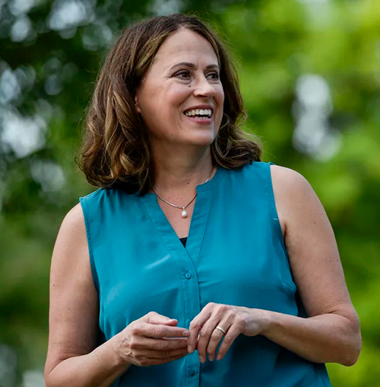

THERESA GREENFIELD

Additional reading: Our one pager on the Iowa Senate election.
Times are grim in America today, but we can’t give up hope. In this pivotal moment, Iowans have an opportunity to elect a strong leader who is going to fight for everyday Americans and seek to unite us, rather than divide us. Her name is Theresa Greenfield, and she’s the Democratic candidate for U.S. Senate in Iowa.
As a self-proclaimed “farm kid with farm values,” Theresa Greenfield will fight for our neglected rural communities who have been shut out of our country’s economic growth for far too long. Watching the Trump administration and its lackeys (including current hardliner Iowa Senator Joni Ernst) haphazardly engage in a trade war that devastated American farmers, Greenfield has a different vision: revitalizing our struggling rural communities by increasing access to capital, broadband internet, and other essential tools. She will stand up for Iowans who are tired of the national sideshow standing in the way of their quality of life.
In fact, Theresa Greenfield will fight for all working- and middle-class Americans. Wealth inequality in this country is out of control, a fact that COVID-19 has laid painfully bare. While 20+ million Americans are unemployed and hundreds of thousands more struggle to afford housing and food, the super-rich collectively made $282 billion in just the first three weeks of the pandemic. This isn’t a fluke, and, frankly, it shouldn’t be a surprise, at least not when legislation like the GOP’s 2018 corporate tax cut benefits the top 20% twice as much as everyone else.
Theresa Greenfield has a plan to stop the dwindling of the middle class and support the struggling working class: bolster Social Security and strengthen unions. Research shows that strong unions mean a strong middle class, something Greenfield experienced firsthand when a workplace accident left her widowed as a young mother with another baby on the way. She credits Social Security programs and her husband’s union benefits with helping her get on her feet and start a successful career in city planning and real estate development.
Theresa Greenfield has also pledged to address the issues that we can’t afford to ignore any longer, including climate change, healthcare, and common sense gun safety. While Joni Ernst irresponsibly refuses to even acknowledge the extensive science on human-caused climate change, Theresa Greenfield is making plans to protect Iowans from its effects, including building infrastructure to prevent devastating floods. She rejects the false tradeoff that tackling climate change means destroying jobs, recognizing an opportunity to generate sustainable, long-term growth in Iowa’s economy by creating jobs in clean energy like wind.
It’s never been clearer that for our nation to be healthy – economically as much as physically – we need affordable healthcare for Americans, including those with pre-existing conditions. Her refusal to accept donations from corporate PACs means that Theresa Greenfield isn’t beholden to special interests that drive copays and prescription drug costs beyond the reach of the average American. Affordable healthcare also means making reproductive healthcare accessible and safeguarding a woman’s right to choose; Theresa Greenfield is committed to protecting women’s rights by promoting access to safe, affordable healthcare, especially in rural communities that currently lack it.
Theresa Greenfield has grassroots support from all 99 counties in Iowa, endorsements from local, state, and national politicians and organizations, and a message that’s bringing hope to voters in these uncertain times. But as an outsider, she doesn’t have the public exposure to match her opponent, which is why we need your help to get her message to voters across Iowa. Join Flip the West in helping to elect a leader with a vision of sustainable prosperity for all Iowans.

